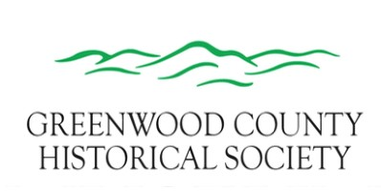
BARBARA ROBISON NICHOLAS
SCHOLARSHIP APPLICATION
- One $300.00 scholarship is available to any graduating seniors that lives in Greenwood County, including home schooled seniors.

- All applicants must have visited the Greenwood County Museum within the last
two - three years.
3. A 200 word minimum essay about why the history of Greenwood County is important to you and the community and why the history of Greenwood County should be preserved.
4. The scholarship recipient will be selected in April by the Scholarship Committee.
5. The scholarship money will be sent directly to the higher education school of the recipient’s choice.
6. No handwritten applications will be accepted.
7. All applications can be emailed (gwchistory@gmail.com), sent or hand delivered to the Greenwood County Museum at 120 West 4th Eureka, Kansas 67045 by midnight Monday April 15, 2024.

- Student’s Full Name (please print)
- High School you will be graduating from? ___________________________
- Grade Point Average? _____________
- What are your plans for further education?
- How do you plan to finance your education?
- What are your career plans?
- Essay as described above in paragraph 3.

